TASK 15:

* Create a Virtual Machine and install google chrome.
* Generalize the Virtual Machine and create managed image.
* Create VM from managed image.

Steps to perform above task:

Step 1: Create Virtual Machine with name ‘vm-gen’.

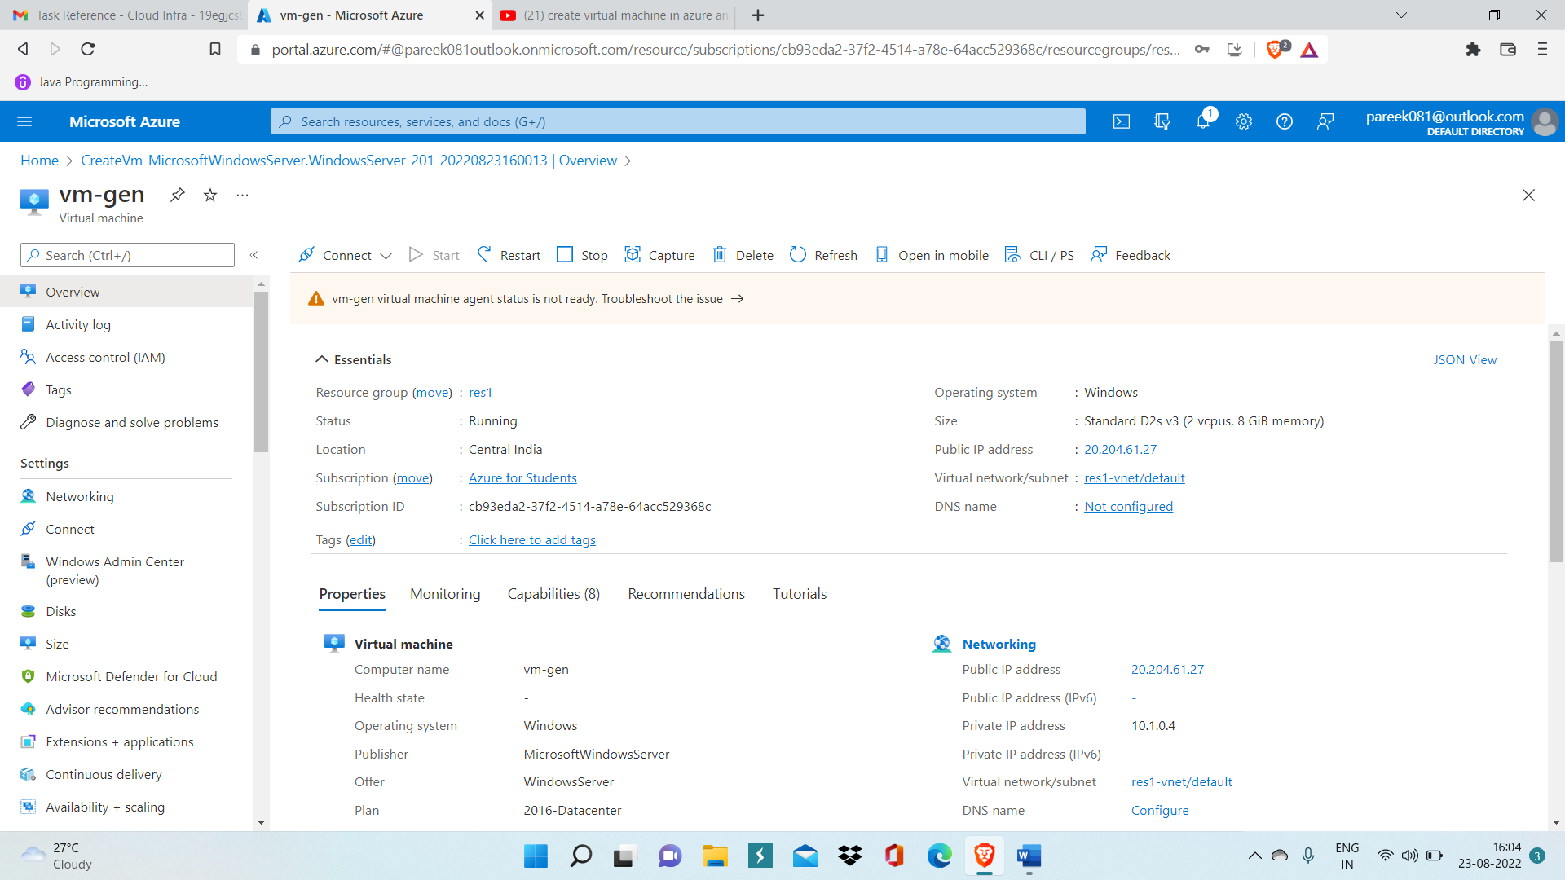

Step 2: Connect to VM using RDP and install Google chrome inside it.

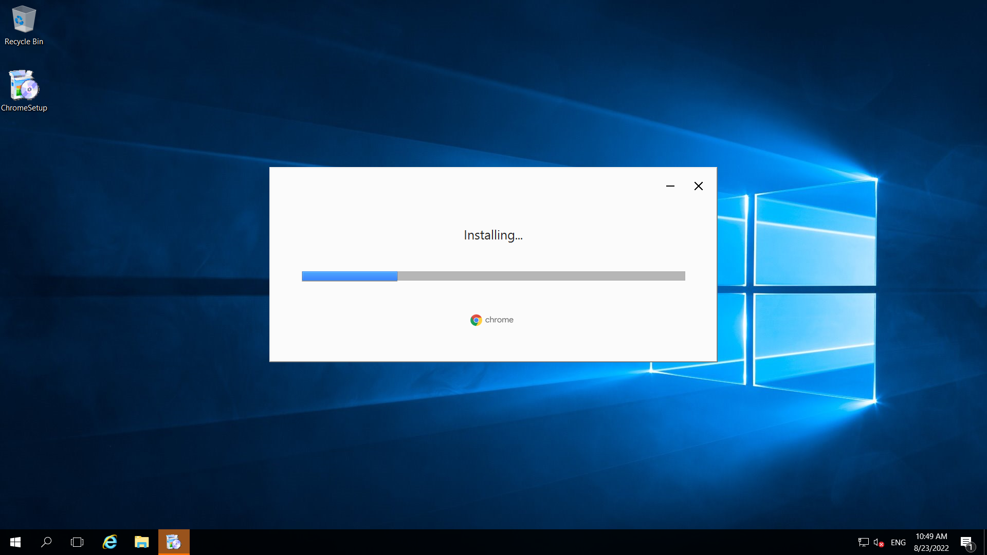

Step 3: Run command: del C:\Windows\Panther to delete Panther directory present inside C drive

Step 4: Then, Run Command:

cd %windir%\system32\sysprep

sysprep.exe/ppbe/genralize/mode:vm/shutdown

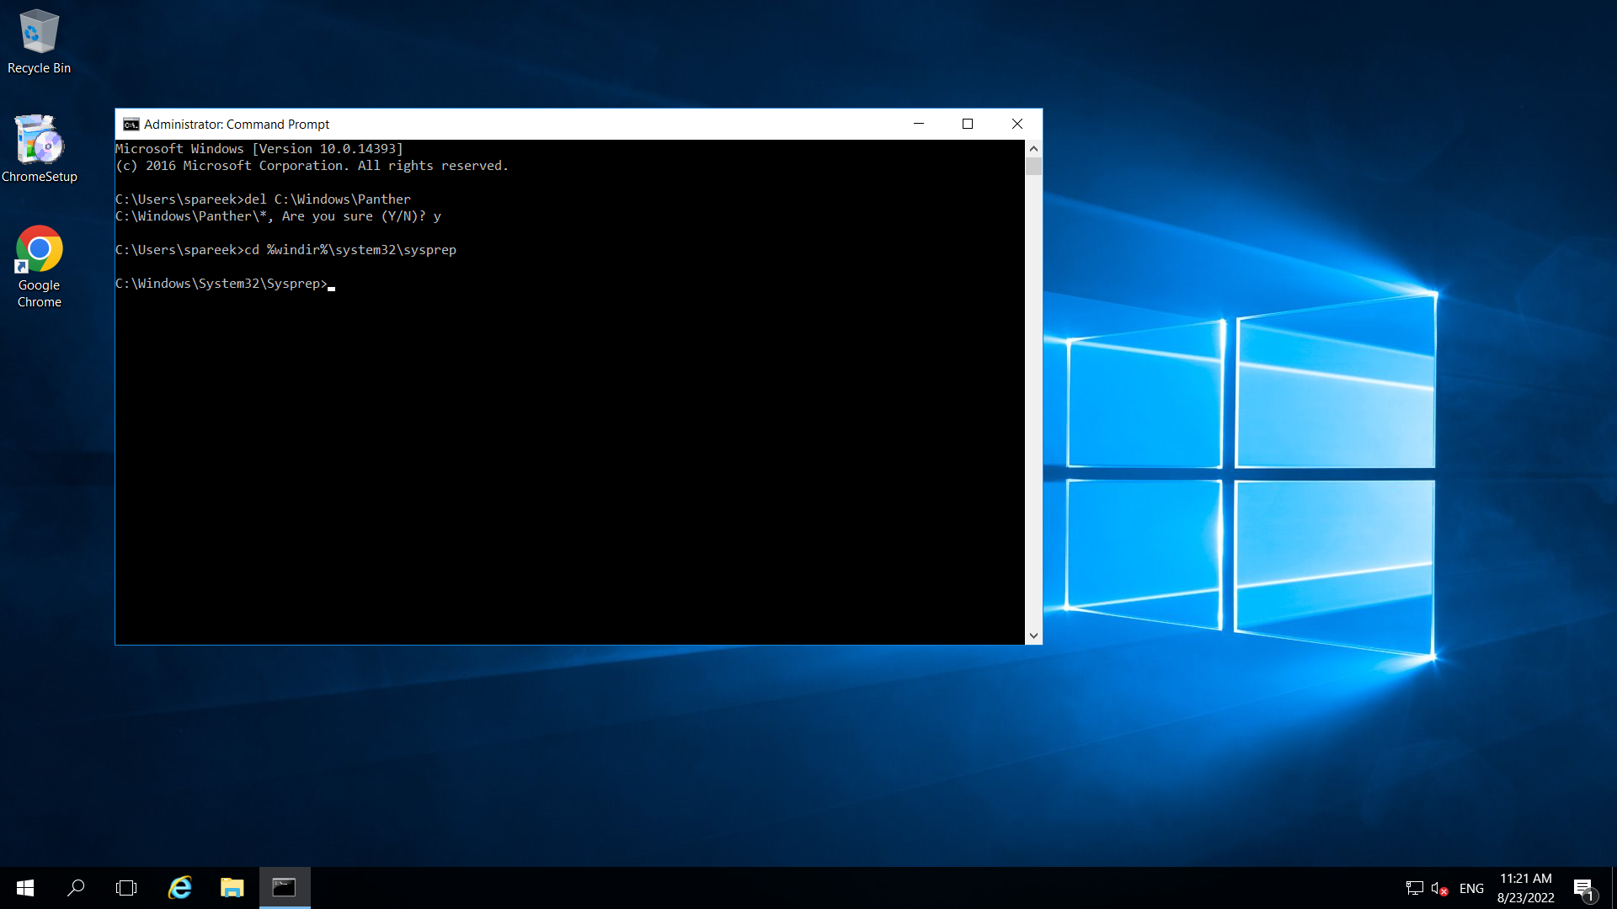

After running above two commands, your VM will get generalized.



Step 5: Now go to overview page of your VM, and click on Capture.

Step 6: Now specify name of your managed image and create.

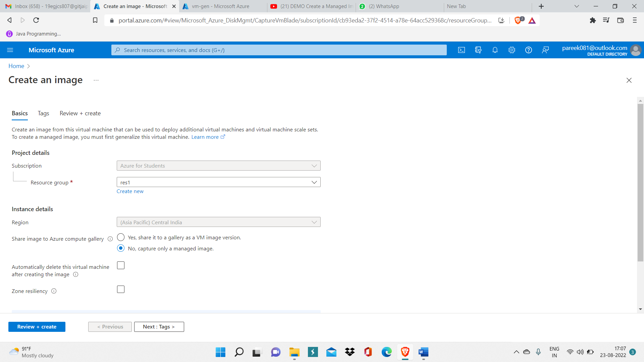

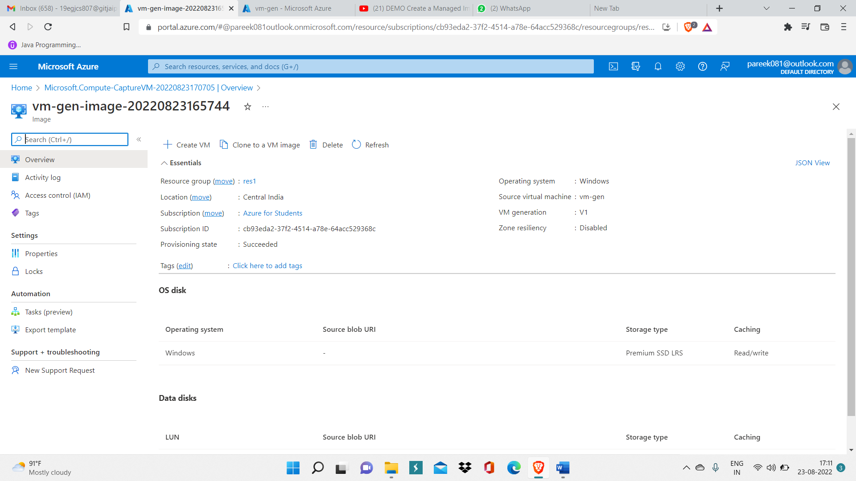

Step 7: Create a virtual image and select your managed image

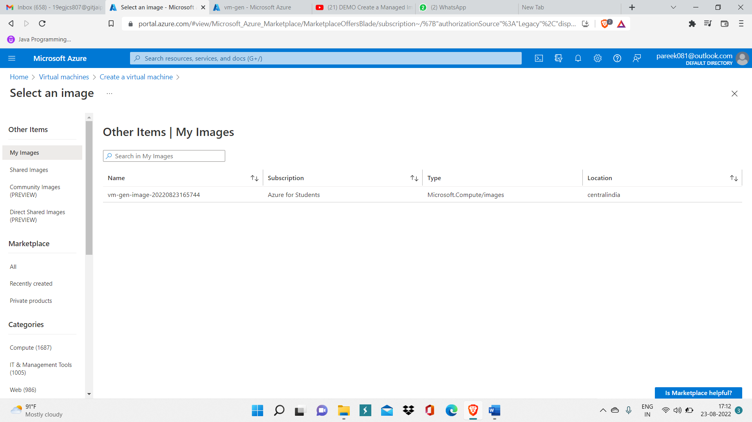

Step 8: Deploy that virtual machine with name ‘vm-managed’ by clicking on create.

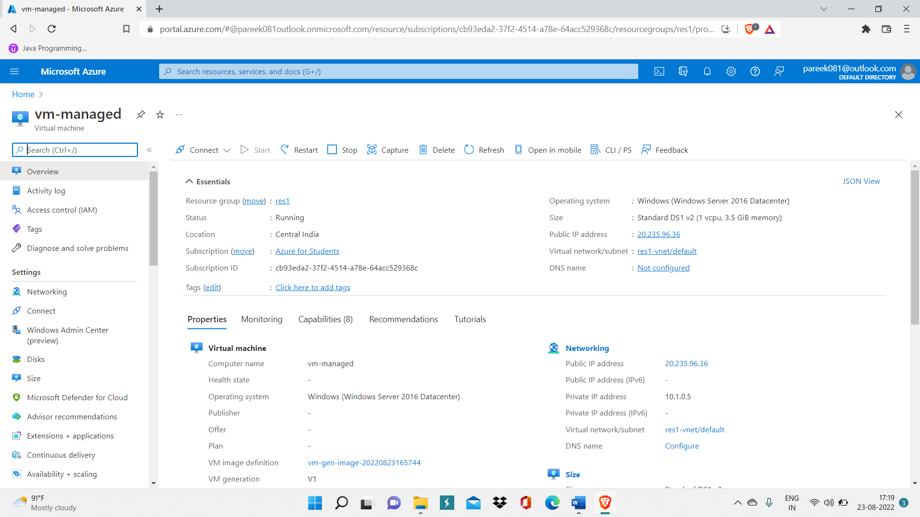

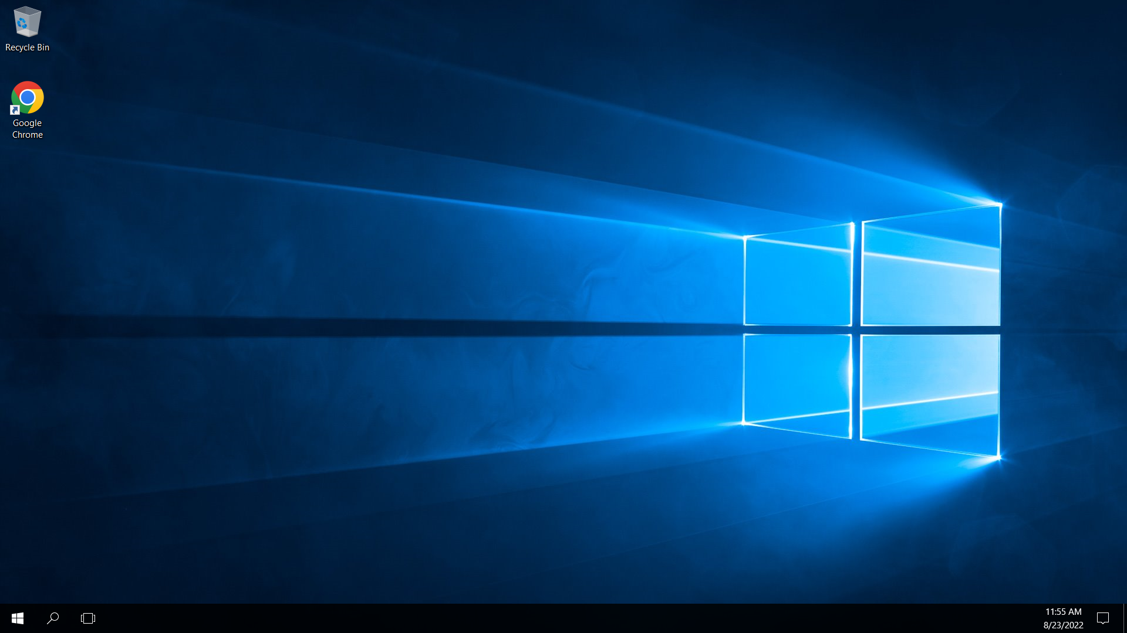

Here, you can see that Google chrome is pre installed in your ‘vm-managed’. This means that we have successfully created managed image.